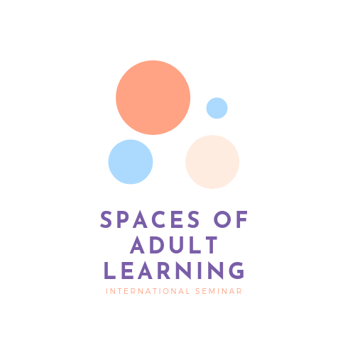
International Scientific Conference
SPACES OF ADULT LEARNING [SAL 2020]
Organised in the partnership with the
Academic Andragogical Society
and under the patronage of EPALE and Czech Andragogical Community
Warsaw, 07-08.05.2020

 | Name and surname
 | Institution name, address
 | Title/degree, position
 | Correspondence address
 | Phone
 | E-mail
 | Title of the speech
 | Abstract in English (up to 1200 characters with spaces)
 | Key words in English (up to 5)
 | Needed devices/equipment | projector, presentation remote control, speakers, …
 | Invoice – please select | YES | NO
 | Billing

Please send your application form and abstract with key words to the following e mail address: sal2020@pedagog.uw.edu.pl by 31.01.2020.
Conference website: http://sal2020.pedagog.uw.edu.pl

GENERAL INFORMATION
Costs of attending the conference: 95 EUR
Payment deadline: 31.01.2020 r.
Transfer to account:
Uniwersytet Warszawski, Wydział Pedagogiczny (230)
ul. Krakowskie Przedmieście 26/28, 00-927 Warszawa
Account number: 69 1160 2202 0000 0000 6084 9408
BIC /S.W.I.F.T BIGBPLPWXXX
IBAN PL69 1160 2202 0000 0000 6084 9408
In the title please fill in: SAL2020 and name of the participant.
The fee includes: refreshments during the coffee break; two lunches; gala dinner; conference materials and participation certificates; optionally a walk around Warsaw or another integration surprise; publications in the scientific journal “Edukacja Dorosłych” ('Adult Education') or in a multi-author monograph (under condition of receiving positive reviews).
I authorize Warsaw University to issue a VAT invoice for participating in the above conference without the recipient's signature.
The invoice is issued for the payer's data
……………………..…………
Conference Participant's signature

***

The General Data Protection Regulation

Information clause:
1. Your personal data is administered by the University of Warsaw (the Controller), with the headquarters in Warsaw at Krakowskie Przedmieście 26/28;
2. The Controller has appointed a data protection officer to supervise the correctness of personal data processing, who can be contacted at this e-mail address: abi@uw.edu.pl;
3. Your personal data will be processed to organize a conference:
4. The basis for the processing of your personal data is the permission for data processing;
5. The provision of personal data is voluntary yet necessary for the achievement of the purposes for which they have been collected;
6. The personal data provided will not be made available to external entities, except for the cases provided for by law;
7. Your personal data will be stored until 31.12.2022.;
8. You have the right of access your personal data, as well as, subject to legal provisions, the right to correct and delete data, limit their processing, transfer them, object to processing, and withdraw consent for processing at any given time;
9. You has the right to submit a complaint to the Inspector General for the Protection of Personal Data (Polish: Generalny Inspector Ochrony Danych Osobowych);
10. Your data will not be processed in an automated manner and will not be profiled.

Clause of consent

I hereby give consent for my personal data to be processed for the purposes of organizing the conference/contest. I am aware that providing personal data is voluntary, but necessary for the purposes for which it was collected, as well as that I have the right to access my data and correct it.

……………………..…………
Conference Participant's signature

ACCOMMODATION (suggested hotels)
HOTEL LOGOS
Address: Wybrzeże Kościuszkowskie 31/33, 00-379 Warsaw
Phone (+48) 22 622 55 62
https://www.hotellogos.pl/
Check in from 2.00 p.m.
Check out until 12.00 p.m.
Accommodation price:
single room (with breakfast) 218 PLN
double room (with breakfast) 288 PLN
HOTEL FACILITY "HERA"
Address: ul. Belwederska 26/30, 00-594 Warsaw
Phone (+48) 22 553 10 00
http://hera.uw.edu.pl/
Check in from 12.00 p.m.
Check out until 10.00 a.m.
Accommodation price:
Single room with bathroom PLN 140,
with shower in the corridor PLN 80
Double room with bathroom 180 PLN,
with shower in the corridor 140 PLN
The price of accommodation does not include breakfast
IBIS BUDGET WARSAW CENTRUM
Address: ul. Zagórna 1, 00-441 Warsaw
Phone (+48) 22 745 36 60
https://www.accorhotels.com/pl/hotel-6401-ibis-budget-warszawa-centrum/index.shtml
Check in from 12.00 p.m.
Check out until 12.00 p.m.
Accommodation price:
single room (with breakfast) 160 PLN
double room (with breakfast) 180 PLN
car park for guests 40 PLN / day
Accommodation prices are approximate and may change slightly
In case you decide to stay in other facility, we recommend the following website:
https://mapy.e-turysta.pl/mazowieckie/warszawa#map=14/21.0612/52.2329
If you wish, we are ready to assist you in booking the hotel. Please, report your need in this area.

Texts can be prepared in the national language, however the slides in the presentation must be in English.

