*Dear Colleagues,*

we invite you to debate devoted to the spaces of lifelong adult learning. The aim of the meeting is theoretical reflection, presentation of research results and exchange of views, as well as dialogue related to contemporary areas, models, goals and functions of adult learning. Our project is closely related to the implementation of the UN Sustainable Development Goals for 2030, directly connected with the idea of Goal 4: ‘Good quality of education’. It refers to key competences in lifelong learning (European Reference Framework, EU 2018).

The meeting is going to be devoted to three spaces of educational practices.

The first are informal learning areas. We would like to pay special attention to an (auto)reflection, modeled by the stream of information and individual experience, or even colloquial knowledge. The shift towards positive valuation of the idea of localism and social commitment prompts reflection on environmental education. All activities, that take place in the microcosms of a person’s life, activities in which – gaining the attitude of open-learners – person assimilates knowledge, shapes attitudes, values and gain skills during his or her own experience, are worth scientific reflection and exchange of views. Research on participation in culture, learning focused on personal interests and passions, (un)realized role of modern technologies in educational acts and processes are an equally interesting field of inquiry.

The second space, related to educational activities in the non-formal sphere, is a space, in which intensive changes take place. Actions of associations, foundations, dissemination of knowledge, work of open education institutions, the sector of non-public educational services, commercial courses, workshops, seminars, trainings, as well as combined forms, devoted to the self-development – are an important area of research, comparisons and analyzes that can be used to increase andragogical knowledge. An interesting problem for researchers and theoreticians of adult education may seem individual strategies of constructing a competence portfolio. Comparisons, illustrating the systems of non-formal education can be also intriguing, as well as reflections on the educational needs of adults, for instance consequences of the development of the global labor market, population migration or technological progress.

Institutional education, understood as formal dimension of adult education, is the third space, abandoned by researchers in recent decades, but worth exploration and reflection. This area of adult education seems particularly interesting according to the possibility of making international comparisons, especially analysis of specificity of adult education systems in particular countries, invited to the debate during the conference. Another important aspects are the transformations, taking place in the area of formal adult education in the last decade, the role of teacher, innovative methodology and other.

We kindly ask you to join the discussion, share your own research results and analysis. We expect various forms of expression and participation: papers, reports, research reviews, scientific posters, workshops, multimedia etudes etc., as well as the mere presence in this event, participation in the discussion, without having to submit a speech.

We will be honoured to welcome you in Poland!

On behalf of the Scientific and Organizational Committee

*Zofia Szarota*

**PARTNERSHIP:**

Academic Andragogical Society [www.ata.edu.pl]

**PATRONAGE:**

Česká Andragogická Společnost [www.candrs.cz]

EPALE – An electronic platform for adult learning in Europe [epale.ec.europa.eu]

**SCIENTIFIC COMMITTEE:**

prof. Agnieszka Bron, Stockholm University (Sweden)

prof. Elżbieta Dubas, University of Lodz (Poland)

prof. Artur Fabiś, Pedagogical University of Cracow (Poland)

prof. Wojciech Horyń, Military University of Land Forces (Poland)

prof. PaedDr. Miroslav Krystoň, University of Banska (Slovakia)

prof. Nadiia Lutsan, Vasyl Stefanyk Precarpathian National University (Ukraine)

dr Tomasz Maliszewski, Polish Naval Academy (Poland)

dr hab. Agnieszka Naumiuk, University of Warsaw (Poland)

dr Adrianna Nizińska, University of Gothenburg (Sweden)

doc. Paed Dr. Ivan Pavlov, PhD., University of Banska (Slovakia)

dr Krzysztof Pierścieniak, University of Warsaw (Poland)

prof. Ewa Solarczyk-Ambrozik, University of Adam Mickiewicz (Poland)

prof. Hanna Solarczyk-Szwec, Nicolaus Copernicus University (Poland)

prof. Agnieszka Stopińska-Pająk, WSB University (Poland)

prof. Zofia Szarota, University of Warsaw (Poland) - Committee Chair

Olga Toderash, Nur-Sultan, (Kazakhstan)

prof. PhDr. Jaroslav Veteška, Ph.D., MBA, Univerzita Karlova (Czech)

prof. Anna Wiłkomirska, University of Warsaw (Poland)

prof. Susan M. Yelich Biniecki, Kansas State University, (USA)

dr Tatiana Zelenova, P. G. Demidov Yaroslavl State University (Russia)

prof. Anna Zielińska, University of Warsaw (Poland)

**THE ORGANIZING COMMITTEE**

Committee Chair*:*prof. Zofia Szarota

The Secretary:   
dr Monika Gromadzka, dr Zuzanna Wojciechowska

Members:   
dr Ewa Dębska, dr Anna Marianowska, mgr Danuta Parlak, dr Krzysztof Pierścieniak

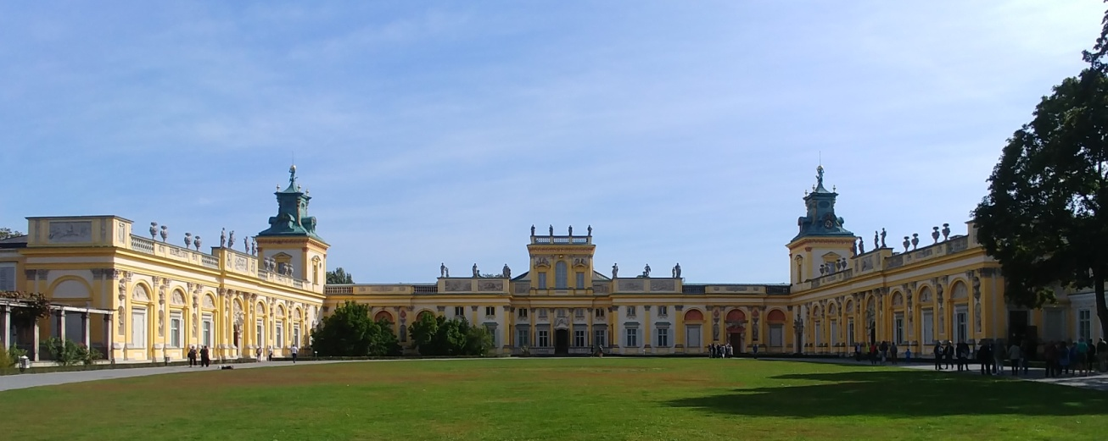

**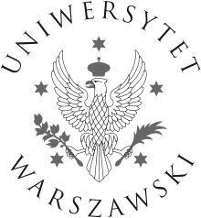GENERAL INFORMATION:**

Date of the conference: **07.-08.05.2020**

Deadline for submitting applications: **31.01.2020**

E-mail address: **sal2020@pedagog.uw.edu.pl**

Web site: **[http://sal2020.pedagog.uw.edu.pl](http://sal2020.pedagog.uw.edu.pl/" \t "_blank)**

Conference languages: **national languages and English**

**Conference venue:**

**Day 1 (07.05.2020):**

Plenary session: University of Warsaw Library (BUW), Dobra 56/66, 00-312 Warsaw

Presentations in sections:

University of Warsaw Library (BUW), Dobra 56/66, 00-312 Warsaw and the Faculty of Modern Languages, Dobra 55, 00-312 Warsaw

**Day 2 (08.05.2020):**

Faculty of Modern Languages, Dobra 55, 00-312 Warsaw

A gala dinner is going to take place in the Column Room of the Faculty of History of the Warsaw University on the Central Campus Krakowskie Przedmieście 26/28, 00-927 Warsaw.

Costs of attending the conference: **95 EUR**

Payment deadline**:** **31.01.2020**

**Travel and accommodation costs are covered by the participants.**

**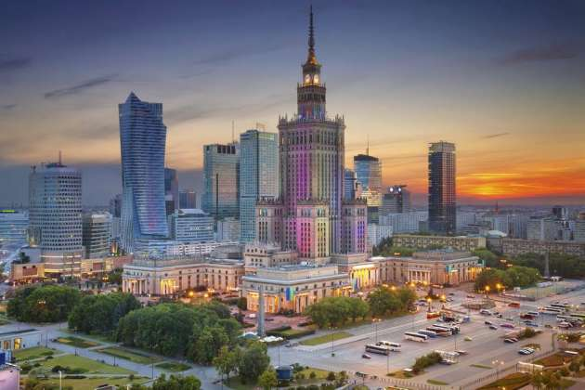** comparic.pl